

**College of Professional Studies**

**Communication and Visualization for Data Analytics**

**Dashboard Development of SFPD Data using Tableau**

*Professor Jack Bergersen*

June, 30th 2023​

|  |  |  |
| --- | --- | --- |
| Index No. | Content | Page No |
| 1 | Introduction | 3 |
| 2 | Research Questions | 3 |
| 3 | Scope | 4 |
| 4 | Methodology | 4 |
| 5 | Overview of the Dashboard | 5 |
| 6 | Data Analysis | 6 |
| 7 | Key Insights | 10 |
| 8 | Conclusion | 11 |
| 9 | Bibliography | 11 |

**Introduction:**

The United States has been historically regarded as a land of limitless opportunities, attracting individuals who aspire to visit, immigrate, or pursue their dreams. People have placed their trust in the ideas of prosperity, success, freedom, and equality associated with the United States. However, it is worth examining whether this dream remains relevant in the present era.

The increasing prevalence of violence, intolerance, gun-related incidents, and other crimes is a matter of great concern for the general public and has a significant impact on overall prosperity. The international community is closely observing this aspect within the United States.

This paper aims to analyze the data of reported incidents provided by the San Francisco Police Department, allowing us to gain insights into the actual circumstances and realities within the city.

The dataset encompasses a collection of incidents reported by the police department from 2018 to 2022. It categorizes crimes into various types, including robberies, assaults, and automobile accidents, and offers detailed information on the incident locations, dates, times, affected areas, and case statuses. The extensive timeframe covered by the dataset enables a comprehensive examination of long-term crime patterns and potential transformations within the city throughout the given period.

**Research Questions:**

We developed a set of research questions that enhance the analysis of data and provide a framework for conducting further study. These questions serve to deepen our understanding of the dataset, uncover additional insight and derive meaningful recommendations based on the data.

The questions framed are:

*Is there a seasonal pattern in the crimes reported in the city and is it consistent?*

*What are the ten most reported incident categories in the city?*

*What are the most common resolutions for the reported incidents in the city?*

*How are the cases filed?*

*When do most vehicle thefts occur in the city?*

**Scope:**

This study is limited to the interpretation of the dataset provided The scope of the study is limited to the dataset, “SFPD incident reports 2018 to present “provided by the Police Department of the City of San Francisco. The data is updated periodically by the department on their website and can be accessed through URL: <https://datasf.gitbook.io/datasf-dataset-explainers/sfpd-incident-report-2018-to-present>

It is important to note that considering the privacy and legal requirements, incidents classified as Confidential and involving Juveniles are excluded in the dataset.

**Methodology:**

The methodology employed in this study relies on widely accepted statistical and analytical techniques. To facilitate data visualization and enhance the user’s understanding of the information derived from the dataset, the Tableau application is utilized. This enables the creation of interactive dashboards that effectively present the data in a visually appealing and comprehensive manner.

Interactive dashboards in Tableau are specifically designed to visualize and communicate the overall story of the data while minimizing cognitive load. The use of visuals, captions, and tooltips helps users absorb content effectively by presenting information in a concise and intuitive manner. Captions provide context and summary information about the visualizations, guiding users in interpreting the data correctly. Tooltips, on the other hand, offer additional details or explanations when users hover over specific data points or elements.

The focus is on delivering key information and facilitating meaningful interactions, ensuring that users can absorb the content and achieve their objectives without being overwhelmed or distracted by unnecessary complexity.

**Overview of the dashboard:**

The dashboard presents an interactive interface that allows users to explore crime data in San Francisco. Users can select the year, month, neighborhood, and police district to view data for the selected period.

Design Theme:

The design and methodology of the dashboard are carefully considered to ensure an intuitive and informative user experience. It is developed using the Tableau interface, which provides a robust platform for creating visually appealing and interactive visualizations.

The dashboard incorporates appropriate captions, tooltips, legends, and data labels to enhance the understandability of the user. Captions provide context and summary information about the visualizations, while tooltips offer additional details or explanations when users interact with specific data points or elements. Legends and data labels aid in interpreting the information presented in the visuals, improving clarity and comprehension.

Interactive filters are included in the dashboard, allowing users to select and manipulate features according to their preferences. These filters enable users to obtain an overall view of the data based on the conditions they apply, empowering them to explore specific aspects or subsets of the data as desired.

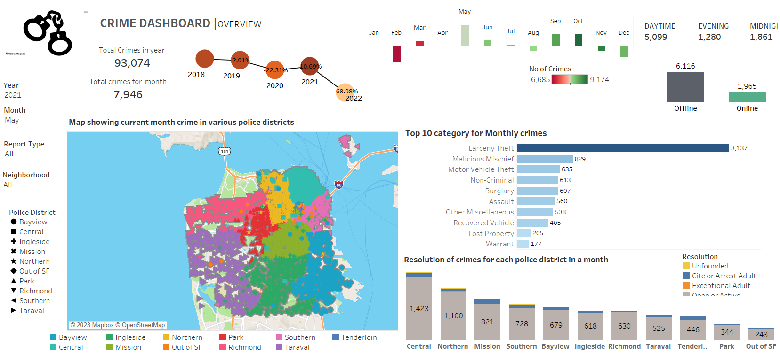

The visual above shows the report of incidents during May 2021 in all neighborhoods in the city covered by all police districts.

The top right corner of the dashboard shows a key performance indicator (KPI) that tracks the number of incidents in the city over time. The KPI also shows the percentage change in the number of incidents from the previous month. The dashboard also includes a bar chart that shows the number of offline and online reports for the selected period.

A map with legends visualizes the intensity of cases based on the geographic location of each police district. The top ten categories of incidents are also shown in a horizontal bar graph. Finally, the bottom right corner of the dashboard shows the caseloads and the current status of each police district in the city.

**Data Analysis:**

To streamline the analysis process and align with the objectives of the study, we have carefully selected a subset of variables from the dataset. These chosen variables have been identified based on their ability to provide meaningful information and facilitate a deeper understanding of the relationships from the dashboard.

Trends of Crimes reported:

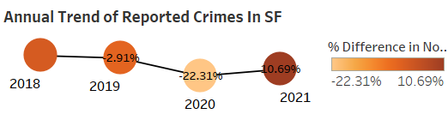

Methodology:

The trend line is the simplest visual that can give the overall picture of the data. This graph uses the aggregation of annual incidents reported in the dataset. The variables used are the Incident year and the aggregate number of crimes. Data for the year 2022 is excluded due to the non-availability of data for full the year

Take away:

The analysis of the trend line reveals a notable decline in overall reported crimes from 2018 to 2020 and a reversal of the trend in 2021. It is crucial to take into account the exceptional circumstances that occurred during the years 2020 and 2021, primarily influenced by the restrictions and limited public life imposed due to the pandemic. The overall crimes have declined relative to the levels in 2018 and 2019 in the city.

1. Is there a seasonal pattern in the crimes reported in the city and is it consistent?

**2018**

**2019**

**2020**

**2021**

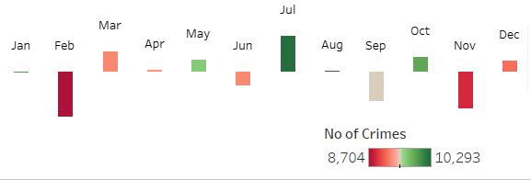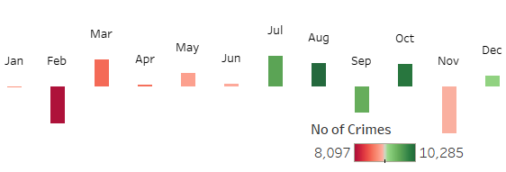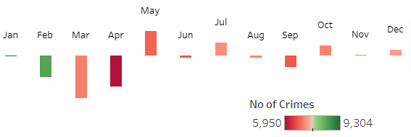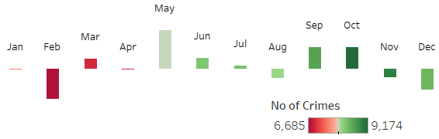

Method: Aggregation of the Month of the incident and year of the incident. This is a waterfall chart. The bar length represents the month-on-month change in crime incidents. Red represents a low number green represents a high number of cases

Take away:

The monthly trend of the incidents reported presents the overall trends on a monthly basis. Excluding the year 2020, the month of October has the highest number of crimes reported in the city, and February portrays the lowest number of incidents. This pattern is consistent across all the years. It becomes apparent that the overall crime rate tends to be elevated from July through October, whereas it remains relatively subdued between February and April. By recognizing these trends, we can gain insight into the seasonal dynamics of reported crimes in the city.

1. How is the overall crime in 2021 and What are the ten most reported incident categories in the city for the year 2021?

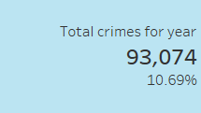

The KPI visual provides the overall count of incidents reported in the year 2021. Compared to the year 2020, the crimes have raised by 10.69%. However, the count is less than the overall crime in 2019.

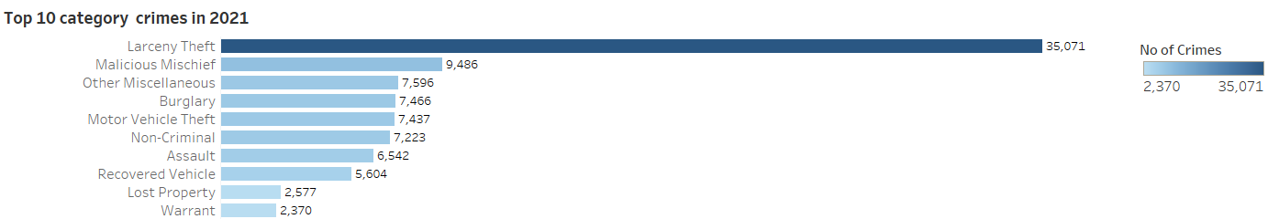

The frequency bar graph displays the top ten types of crimes in the year 2021. It uses variables incident category and year of the incident.

The city reported the highest number of incidents in the category “Larceny Theft” followed by Malicious Mischief, other miscellaneous, and other categories of crimes. In 2021, more than one-third of the overall crimes reported are categorized as Larceny theft which includes cases like shoplifting, pickpocketing, and purse snatching. Across all the years and in all areas of the city larceny theft is prevalent. Data indicates that larceny-theft incidents are more than 35% of the overall incidents reported.

1. What are the most common resolutions for the reported incidents in the city?

The Department of Police has classified the resolution of crimes as Active, Exceptional adult, Cite/Arrest Adult, or Unfounded. The department has classified the data as resolution, however, it would be appropriate to consider it as the status of the case. Based on this field the incidents are further analyzed for each police district to understand the status of the cases across districts and observe them. The bar graph presents the status of incidents reported in the year 2021.

The graph uses variable Police district and aggregation of incidents in the year 2021 from the dataset.

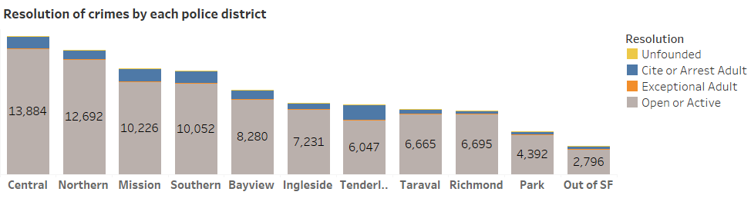

From the visual, we can observe that there are 11 districts of police in the city. The highest number of incidents are reported in the Central followed by the northern district. The majority of the cases are in open status and less than 10% of cases lead to arrests. The Mission district of police has the highest number of arrests in the city.

1. How are the reports filed in the city?

The department has facilitated the residents of the city to file the reports online. An analysis is conducted to look for the overall online cases filed in the city. The bar plot of a number of reports based on their filing type on an annual basis is presented below.

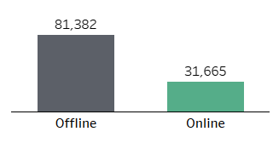

**2018**

**2019**

**2020**

**2021**

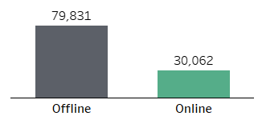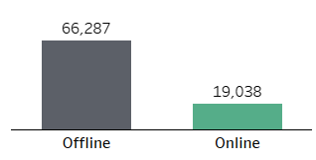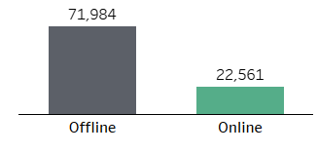

From the graph, we can observe more than 22000 cases are filed in the year (post-pandemic) which is lower than the number of online filed cases in the years 2018 and 2019.

1. When do most vehicle thefts occur in the city?

An analysis is conducted to observe if there is any pattern in the vehicle thefts reported and also to find the times when crimes occurred the most.

Overall vehicle theft category of incidents reported ranged between 6856-10718 yearly.

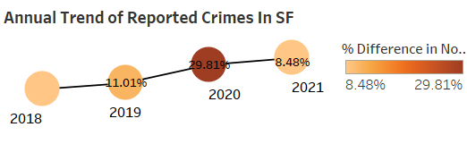

From the trend line, we can observe that the crime rate is increasing in the city. In contrast to the decline in crime rate in the year 2020 vehicle thefts in the year have surpassed around 30% relative to 2019.

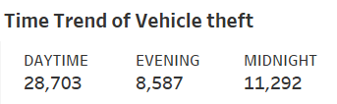

From the data, we can affirm that the majority of vehicle thefts happen during the daytime. This KPI visual uses the fields Time, aggregate crimes, and filters are applied to select data related to vehicle theft from the dataset. The trend is consistent over all the years.

**Key Insights:**

1. In San Francisco, the general trend of recorded crimes showed a drop from 2018 to 2020, however, this trend was reversed in 2021. However, it's crucial to take the COVID-19 pandemic-related unusual conditions of 2020 and 2021 into account.

2. With the exception of 2020, the monthly trend study of crime reporting showed constant tendencies, with October consistently having the largest number of events and February typically having the lowest.

3. The most often reported incident type in San Francisco in 2021 was "Larceny Theft," which was followed by "Malicious Mischief" and other ad hoc categories. This pattern persisted during the years that were examined.

4. The bulk of reported crimes remained active and few instances led to arrests. The majority of recorded events were in the Central and Northern areas.

5. Although the department has facilitated online case filing for non-emergency crimes, the majority of occurrences were reported offline. There is a decline in online filings post-2019.

6. The study of the data from October 2021 revealed that daytime thefts of vehicles were more common in San Francisco.

**Conclusion:**

The data from the incident report analysis provided useful insights. There was a marginal decline in reported crimes between 2018 and 2020, which may be ascribed to initiatives of law enforcement operations. The COVID-19 pandemic-influenced extraordinary conditions of 2020 and 2021 must be taken into account, nevertheless.

Initiatives to prevent Larceny theft are crucial as it accounts for more than 35% of the overall crime frequency. Advanced security solutions can play a significant role in targeting high-risk areas and deterring larceny theft. This would significantly reduce the overall crime rate in the city. Policymakers and law enforcement organizations may use these insights for preventing crimes.

Overall the city of San Francisco is relatively safe as the city has not reported any significant violent crime pattern but the residents and visitors must be vigilant.

**Bibliography:**

Police Department Incident Reports: 2018 to Present | DataSF | City and County of San Francisco. (2023, June 27). <https://data.sfgov.org/Public-Safety/Police-Department-Incident-Reports-2018-to-Present/wg3w-h783>​

SFPD Incident Report: 2018 to Present - DataSF | Dataset Explainers. (n.d.). <https://datasf.gitbook.io/datasf-dataset-explainers/sfpd-incident-report-2018-to-present>​

Crime Dashboard | San Francisco Police Department. (2022, October 25). San Francisco Police Department. <https://www.sanfranciscopolice.org/stay-safe/crime-data/crime-dashboard>​

Tableau Community Forums. (n.d.). <https://community.tableau.com/s/topic/0TO4T000000QF9nWAG/tableau-desktop>

Knaflic.C.N .(2015) . Storytelling With Data: A Data Visualization Guide for Business Professionals. Wiley